SQL ANSWERS!!!
3.11
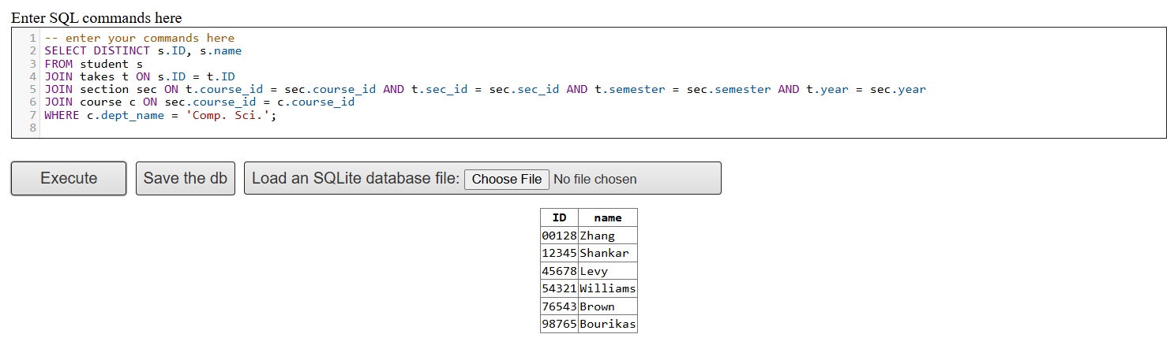
a)

b) 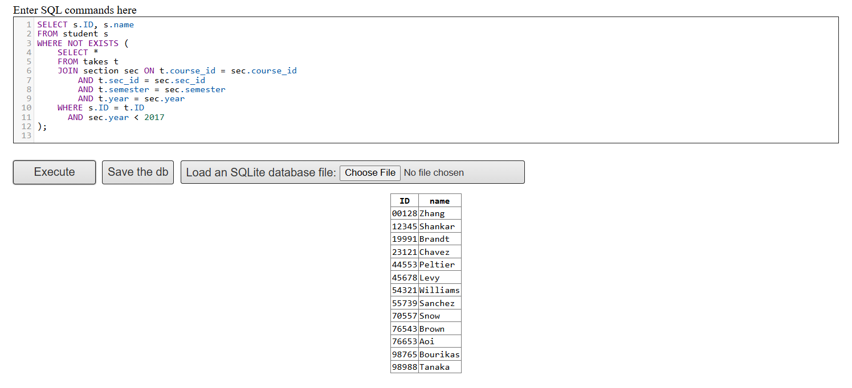
c) 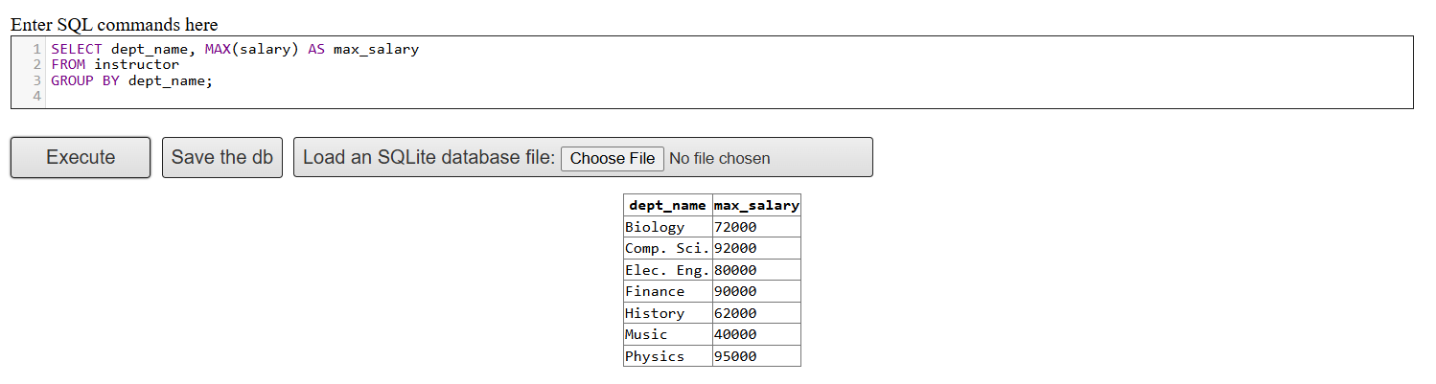
d) 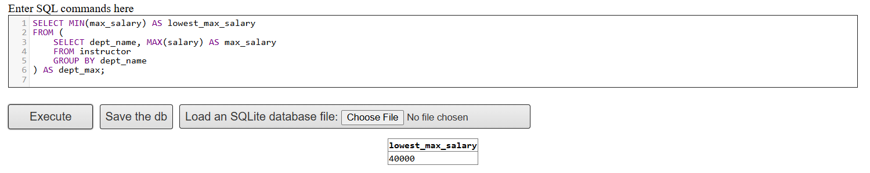
3.12
a) 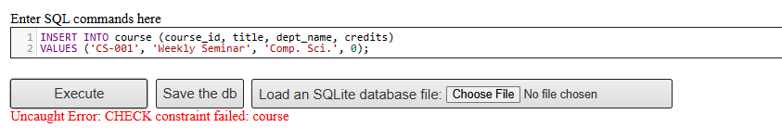
Since the course table has a CHECK (credits > 0) constraint, inserting a 0-credit course will result in an error.
b)
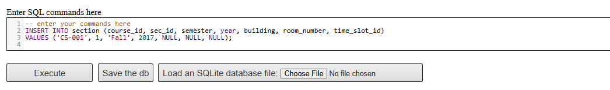
c) 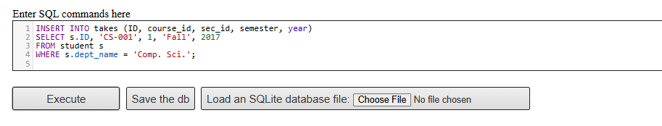
d) 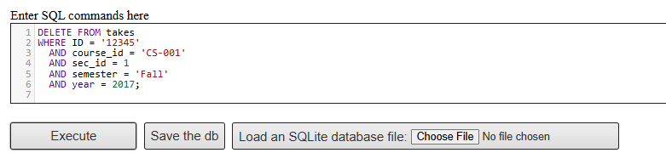
e) 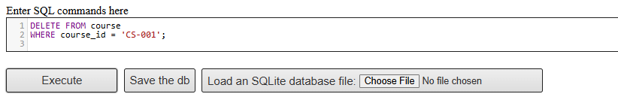

f) 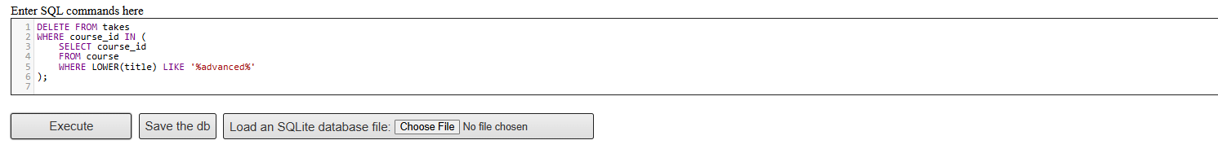
3.13
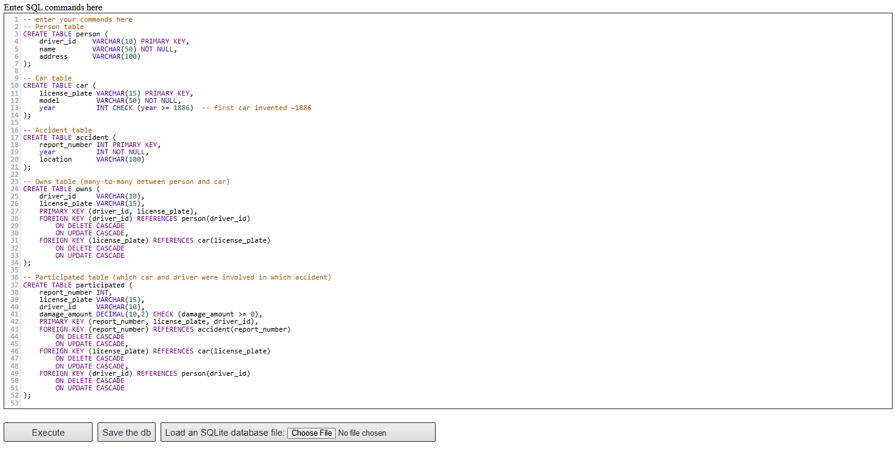
3.14
a) 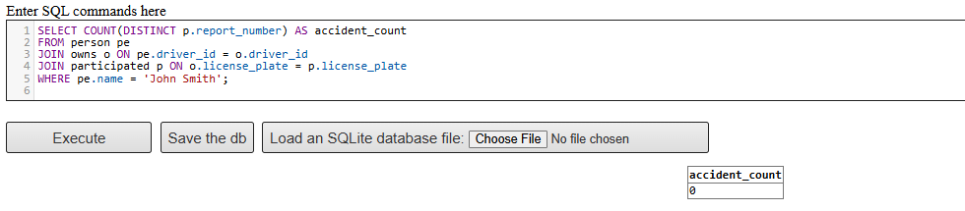
b) 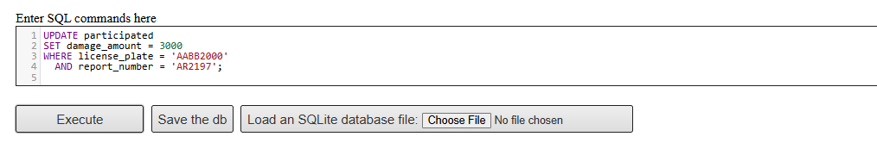
3.15
A) 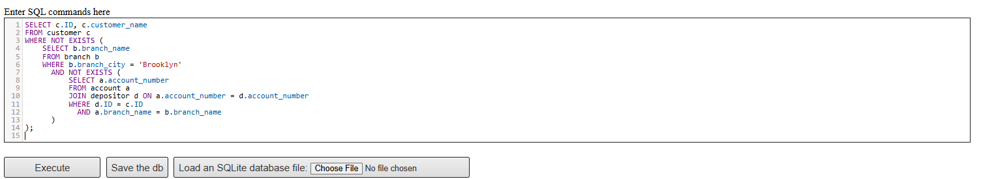
B)
c) 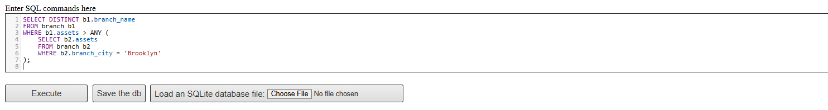

3.16
A) 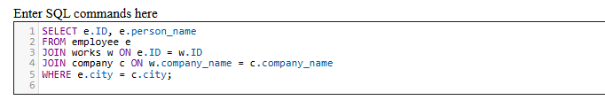
B)
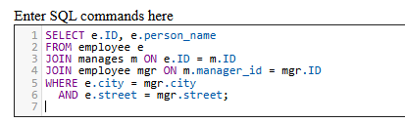
c)
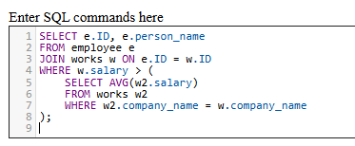
d)
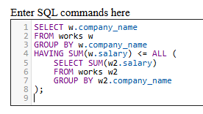
3.17
A)
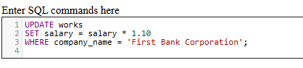
b)
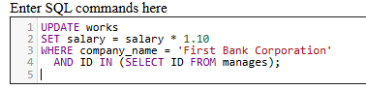
c)
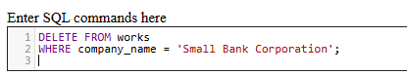
3.18
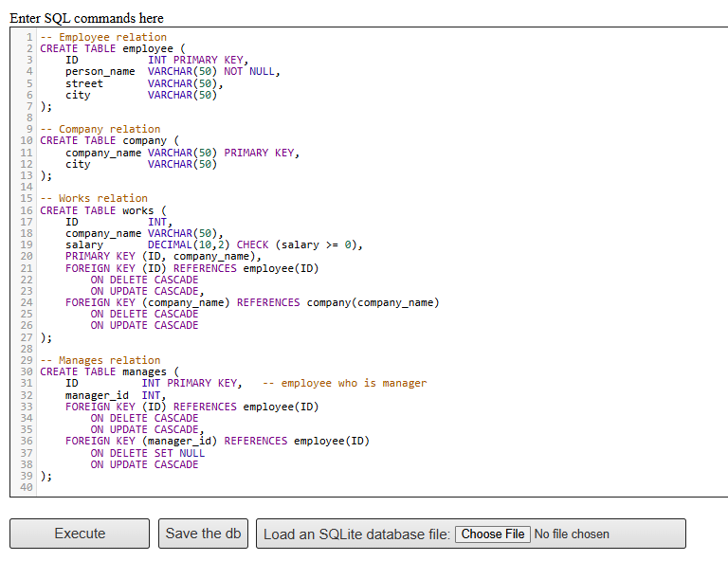
3.19
Reasons why null values might be introduced
- Information is missing or unknown at the time of data entry
(e.g., an employee’s manager is not yet assigned).
- Attribute is not applicable for a given tuple
(e.g., manager_id is not applicable to the CEO, so it may be NULL).

4.14
The reason adding section doesn’t change anything is because takes already has the keys (course_id, sec_id, semester, year) that point to section. Every record in takes must already match a valid section because of the foreign key. So when you do a natural join with section, it just finds the same matching row that already exists—it doesn’t add or remove anything. And since the query doesn’t actually use any extra attributes from section, the result looks exactly the same.
4.15
A natural join automatically matches columns with the same names. In this case, both section and classroom share the columns building and room_number. So if we want to rewrite it without NATURAL JOIN, we can just do an explicit INNER JOIN using those two columns.
SELECT * FROM section NATURAL JOIN classroom;
can be rewritten without using a natural join as:
SELECT *
FROM section
INNER JOIN classroom
USING (building, room_number);
Here, the USING (building, room_number) clause explicitly specifies the join condition that the natural join would have applied automatically.
4.16
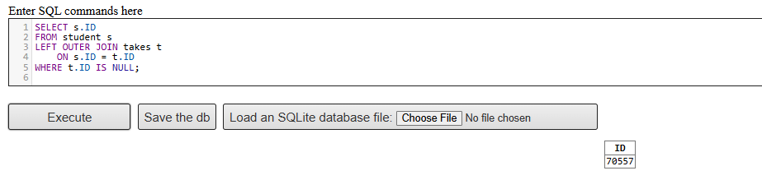

4.17
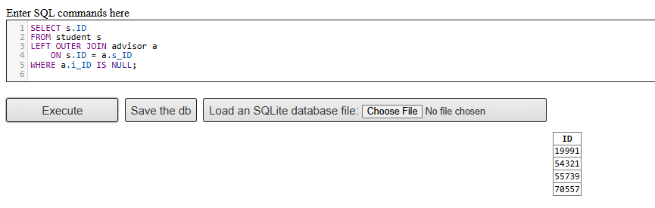
- The LEFT OUTER JOIN ensures every student is included.
- If a student has no advisor, the corresponding i_ID will be NULL.
- The WHERE a.i_ID IS NULL condition filters exactly those students who lack an advisor.
4.18
Using with outer join
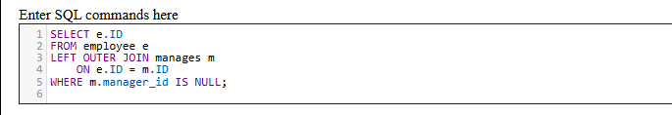
Using without outer join
